Week 7 Practical
Data Center Architecture & Cloud Concepts

Student Name:  Lindiwe Constance Duiker | Student Number:  20261297

TASK 1
STEP 1
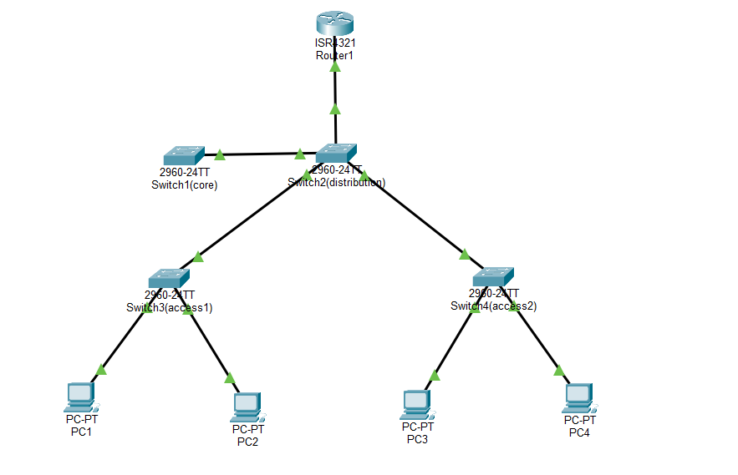
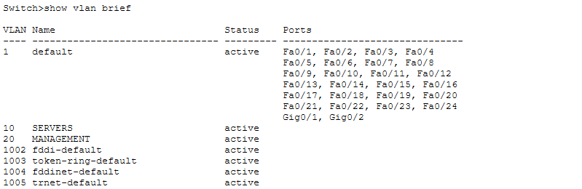
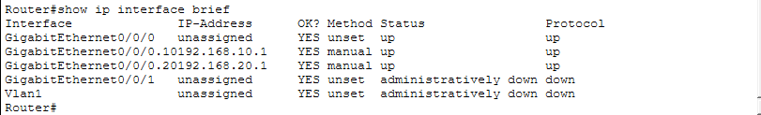

STEP 2

- VLANs must be created on every switch so that switches can recognise and forward traffic for those VLANs correctly.
- An access port carries traffic for only one VLAN and is normally used for end devices such as PCs and printers. A trunk port carries traffic for multiple VLANs using VLAN tagging. Uplink connections between switches should use trunk ports so that all required VLAN traffic can pass between switches.
- Show vlan brief
STEP 3

- IEEE 802.1Q. It is used because it supports VLAN tagging, allowing multiple VLANs to travel across a single trunk link.
- No. not all VLANs should always be allowed on every trunk. Restricting VLANs improves security, reduces unnecessary traffic, and prevents unauthorized VLAN access.

TASK 2

- ip routing, without this command the switch cannot route traffic between VLANs, meaning devices in different VLANs will not be able to communicate.
- You can check using show vlan brief and show ip interface brief conditions.
- In router-on-a-stick, the physical interface acts only as a trunk link carrying traffic for multiple VLANs.
- You can verify inter-VLAN routing by assigning IP addresses to PCs in different VLANs and testing connectivity using the ping command.
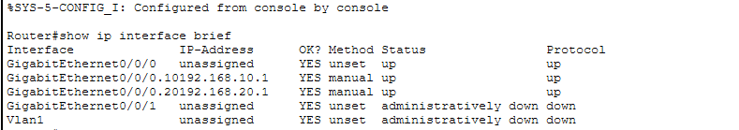

TASK 3

- The real IP address belong to the physical gateway devices. The virtual IP address is shared address created by HSRP or VRRP for redundancy. End devices use the virtual IP address as their default gateway so that communication continues even if one gateway fails.
- The device with the highest priority becomes the active gateway in HSRP. If priorities are equal, the device with the highest IP address becomes active.
- If the active/master gateway fails, the standby gateway automatically takes over the virtual IP address and continues forwarding traffic.
- The preempt command allows a higher-priority devices to take back the active role after recovering from a failure.it is enabled when you want the preferred gateway to automatically become active again. It may be disabled to prevent unnecessary switching between devices.

TASK 3
# | Source | Destination | Test | Protocol | Pass/Fail
1 | Server in VLAN 10 | Server in VLAN 10 | Same-VLAN ping | ICMP | pass
2 | Server in VLAN 10 | Server in VLAN 20 | Cross-VLAN ping | ICMP | pass
3 | Server in VLAN 10 | Virtual gateway IP | Gateway reachability | ICMP | pass
4 | Server in VLAN 20 | Server in VLAN 10 | Reverse cross-VLAN | ICMP
5 | Server in VLAN 10 | Simulated web server | HTTP GET (port 80) | HTTP
6 | Admin PC | Management SVI | Management plane access | ICMP

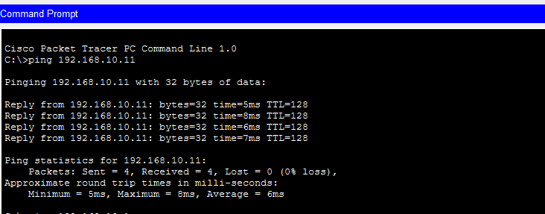

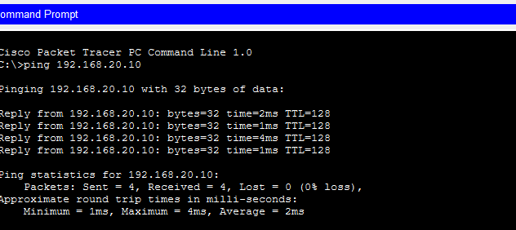

- Layer 1
I checked whether the cables were correctly connected and whether the interfaces were in the group up/up state.

- Layer 2
I checked whether the correct VLANs were created and whether the switch ports and trunk links were configured correctly.

- Layer 3
I checked the IP address, subnet masks, default gateways, and verified inter-VLAN routing using ping tests.

- Layer 4
I checked whether the required services and communication ports were functioning correctly.

